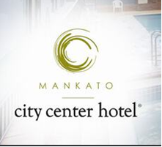

RENOVATION LETTER

Dear Valued Guest,
Thank you for choosing the Mankato City Center Hotel as your accommodation provider during your stay in Mankato. As part of our continued commitment to enhance our property and service, we are currently in the process of renovating our guestrooms and entire hotel to become a Holiday Inn. We are still in the planning phase of our project, and plan to begin the remodel later this fall. It really is crazy how much goes into planning a remodel of this capacity.
During this time, we have been able to continue to accommodate our guests, but we don’t have all amenities available. As a result of the upcoming remodel, we will not have a hot tub available, our restaurant is not open, and we do not have a hot breakfast. We do have a small grab and go option that would include a few items such as granola bar, a bottle of juice, muffins, and a fruit cup.
Our hotel needs a lot of work in a lot of areas, but we are working to something that will truly be amazing.
The Mankato City Center Hotel strives to be the best hotel in the city, and we appreciate your continued support as we prepare for the renovation.
If you have any comments or concerns, please email Management, Becky Folkers, at becky@sloweymgmt.com.

Sincerely,
The Team at the Mankato City Center Hotel – Soon to be Holiday Inn

